The Promise (and challenge) of Local TV Programmatic
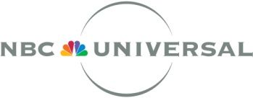
Programmatic has become a small but growing part of national TV buying. NBCUniversal rolled out programmatic capabilities across all of its networks earlier this year, and other networks have experimented with it. But programmatic has been slower to come to local TV. A new forecast from BIA/Kelsey, which tracks local advertising, says just 1 to 2 percent of spot TV is sold programmatically.
MediaLife 8.4.16
http://www.medialifemagazine.com/promise-challenge-local-tv-programmatic/

