The Rise of Interactive Ads as TV, Digital Blend
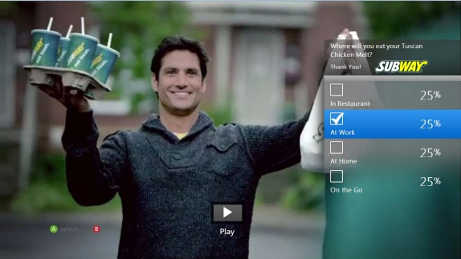
The Interactive Advertising Bureau's Eric John says that the increased use of connected TVs and over-the-top viewing are boosting interactive opportunities and that from what he's experienced, interactive ads are sparking an interest from marketers that's only surpassed by six-second ads.
FierceCable 6/25/18
https://www.fiercecable.com/video/can-interactive-tv-and-advertising-find-audience
Image credit:
http://marketingmag.ca/wp-content/uploads/2012/09/ControllerMock.jpg

