The Rise of the Female Showrunner
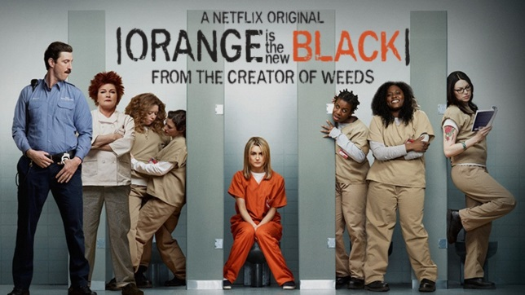
Jenji Kohan, creator of "Orange Is the New Black," is among the women helping to pave the way for female showrunners to produce and write successful series like the "The Affair," "Empire," and "Transparent." Women have slowly increased their income as television writers over the last decade, according to a Writers Guild of America West report looking at 2012 figures, but female screenwriters still only made 77 cents for every dollar their male counterparts earned.
Variety 8/4/15
http://variety.com/2015/tv/news/jenji-kohan-female-showrunners-shonda-rhimes-1201555729/

