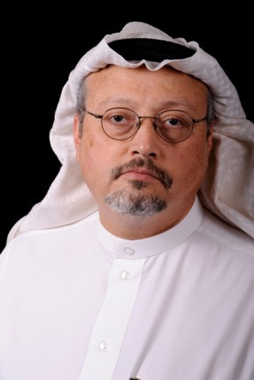
The Silencing of A Saudi Truth Teller
The disappearance of Saudi journalist Jamal Khashoggi last Tuesday has drawn the attention of the media world. His reported murder at the hands of Saudi government agents at the kingdom’s consulate in Istanbul threatens to spark an international incident.
Columbia Journalism Review 10.8.18
https://www.cjr.org/the_media_today/jamal-khashoggi-saudi-arabia.php
Image credit:
https://www.washingtoninstitute.org/uploads/Images/Staff/KhashoggiJamal.jpg

