The Soaring Popularity of Branded Hashtag Emojis
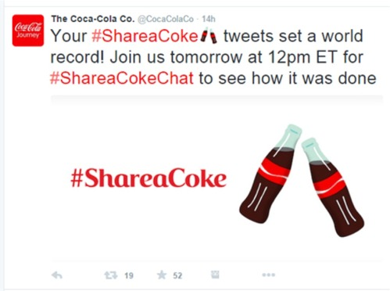
Brands such as Dove, Starbucks, Coca-Cola and Toyota are taking over Twitter with their own emojis. Wieden+Kennedy created the first branded hashtag marketing campaign on the platform for Coca-Cola as part of #shareacoke, and it got over 170,500 global mentions in the first 24 hours.
Adweek 12/1/15
http://www.adweek.com/socialtimes/how-the-branded-hashtag-emoji-is-taking-over-twitter/630826

