The Village Voice Ends Editorial Production
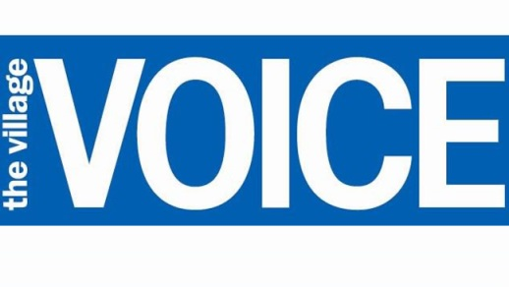
“Today is kind of a sucky day. Due to the business realities, we are going to stop publishing Village Voice new material,” said Barbey on the call. “About half the staff, it’ll be last day today. About half the staff staying on to wind things down and to work on the archive project.”
Columbia Journalism Review 9.6.18
https://www.cjr.org/business_of_news/village-voice-news-layoff.php

