NBC's Goldsmith on Making "This Is Us" a Social Sensation
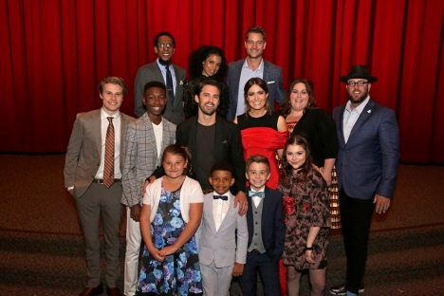
NBC's Jared Goldsmith discusses the network's social strategy to create viral buzz around "This Is Us," starting with attracting 105 million views for the first season's trailer on YouTube and Facebook. "We think of ourselves as one of the fans, and so we do things like work with the talent to create personalized birthday messages that we'll send out via social media to an individual to give them a special message," Goldsmith says.
The Drum (Scotland) 4/24/18
http://www.thedrum.com/news/2018/04/24/how-nbc-harnesses-social-buzz-fuel-fan-fervor-us
Image credit:
https://i.amz.mshcdn.com/jwV7_t9C-L3La7vxTXTqouwP5LE=/fit-in/1200x9600/https%3A%2F%2Fblueprint-api-production.s3.amazonaws.com%2Fuploads%2Fcard%2Fimage%2F414652%2F354c98ed-a160-4cec-a1d2-1fe5ea5da126.JPG

