Time Warner Cable announces N.Y. Rate Hikes Following Merger
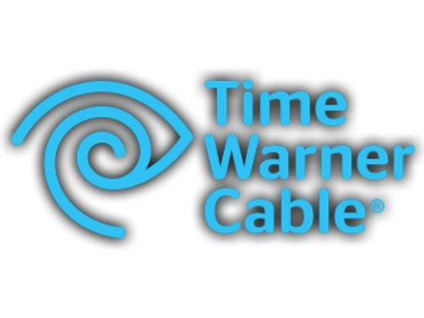
Time Warner Cable, almost immediately after receiving approval from New York regulators to merge with Charter Communications, is informing customers in the state that pay-TV and broadband rates will be increasing. Nathalie Burgos, a spokeswoman for Time Warner Cable, said, "The price changes don't have anything to do with the merger," Burgos said. "We still operate as an independent company."
Times Union (Albany, N.Y.) 1/18/21

http://www.timesunion.com/business/article/After-state-approves-Charter-deal-Time-Warner-6767712.php

