Tips to Master Listicles
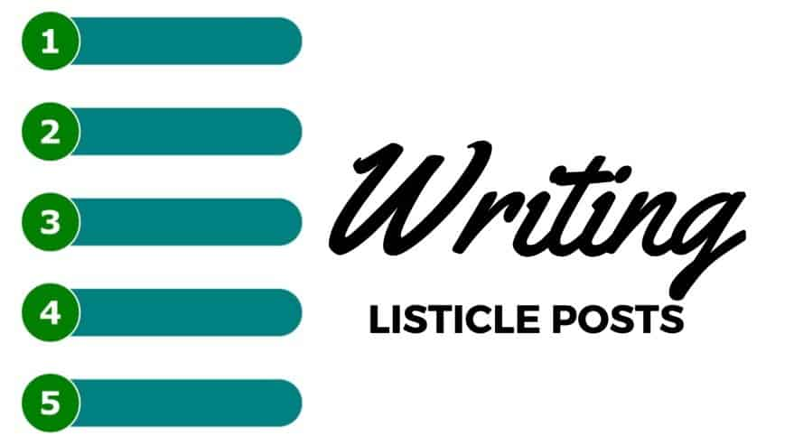
Web visitors love lists because they attract their attention and are easy to skim, writes Ann Wylie. She offers 10 tips to help communication pros tap this irresistible form of content to amplify a message and boost engagement, including logical organization and the right number of items.
PRSAY 12/12/19
https://prsay.prsa.org/2019/12/12/on-the-a-list-10-tips-for-creating-winning-listicles/
Image credit:
https://cdn.digitalmarketingwebdesign.com/wp-content/uploads/20180708235251/Writing-Listicle-Posts.jpeg

