TiVo Announces Voice-Controlled DVR
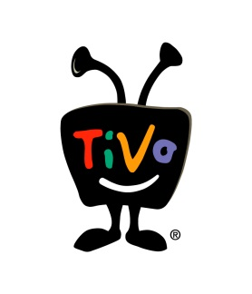
DVR maker TiVo today officially confirmed the launch of its new DVR, the TiVo BOLT VOX, and its smaller counterpart, the TiVo Mini Vox, following yesterday’s leak. As had been reported, the biggest change is that these are the first TiVo DVRs to include a voice remote control.
TechCrunch 10.24.17
https://techcrunch.com/2017/10/24/tivo-officially-announces-its-voice-controlled-dvrs-the-bolt-vox-and-mini-vox/

