T-Mobile May Use 4K Dongle for TVision
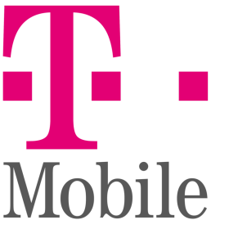
T-Mobile will deploy a dongle-style device that supports 4K technology in the upcoming Android TV version of TVision, Chinese vendor SEI Robotics suggested in documentation filed with the Federal Communications Commission. The design is said to be similar to DISH Network's AirTV Mini streaming device for Sling TV.
Light Reading 7.27.20
https://www.lightreading.com/cablevideo/t-mobile-sizes-up-streaming-dongle-for-tvision-service-/a/d-id/762702?_mc=RSS_LR_EDT

