Travel industry embraces Internet of Things
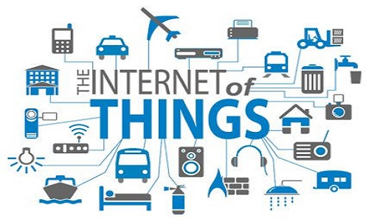
Travel and hotel industry executives report that their companies will spend $128.9 million each on Internet of Things projects, and 86% of airline IT executives believe that the IoT will present benefits over the next three years, eMarketer reports. The industry is using the IoT to streamline back-end functions and to personalize consumer experiences.
eMarketer 1/21/16
http://www.emarketer.com/Article/How-Internet-of-Things-Transforming-Travel/1013487

