TV Channels Getting Crushed
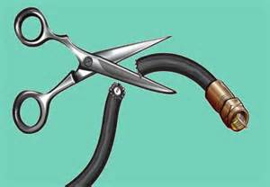
TV channels with the biggest subscriber losses over the last four years. MTV and VH1, which are great for simply flipping to without knowing exactly what's on, saw big losses, as did ESPN and ESPN2. The Weather Channel saw the biggest dip.
Business Insider 10.5.16
http://www.businessinsider.com/tv-channels-hurt-by-cord-cutters-2016-10
image source:
http://carlosrull.com/wp-content/uploads/2016/06/living-without-cable.jpg

