Big Bang: The Coming Upheaval in Local TV
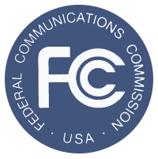
The FCC is holding an auction in which TV stations will sell back their broadcast franchise—their place on the television spectrum—at potentially huge valuations well over what they would fetch on the open market. A great number of TV stations could stop broadcasting over the air.
MediaLife 11.2.15
http://www.medialifemagazine.com/big-bang-the-coming-upheaval-in-local-tv/

