Twitter Backs the Proposed Honest Ads Act
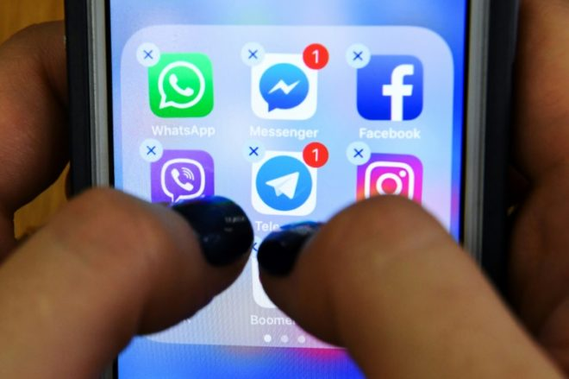
Twitter is joining Facebook in supporting the Honest Ads Act, a proposal that calls for platforms with a minimum of 50 million users to retain and make available for public viewing all political ads bought by groups investing more than $500. The bill would also require political ads to be labeled with "clear and conspicuous" disclosures and would require that platforms make "reasonable efforts" to prevent ads from being bought by foreign agencies.
The Verge 4/10/18
https://www.theverge.com/2018/4/10/17220112/twitter-honest-ads-act-compliance-russia-election-interference-transparency
Image credit:
https://media.24matins.uk/2018/04/aef714b12941d47704905deda5c5e005b99cab55-660x439.jpg

