Twitter Bots Challenge Racist Trolls
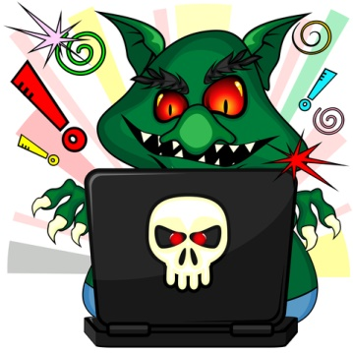
Researchers are using Twitter bots to scold trolls to raise the tone of discourse and to determine the best approach to improve online behavior. Criticism from bots that present themselves as high-profile white people appear effective at reducing trolls' use of racist slurs.
New Scientist 8/3/16
https://www.newscientist.com/article/mg23130851-300-troll-hunters-the-twitterbots-that-fight-against-online-abuse/

