Twitter Halts User Verification, Saying It's 'Broken'
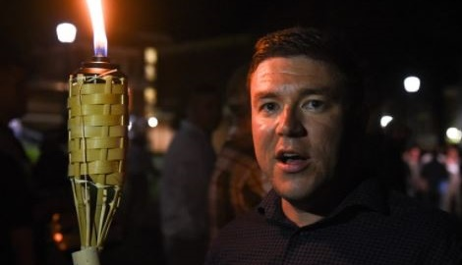
The social-media company drew criticism for the process this week after it conferred a blue check mark on the account of Jason Kessler, who is credited with orchestrating the white supremacist rally in Charlottesville, Virginia, in August.
Advertising Age 11.9.17
http://adage.com/article/digital/twitter-halts-user-verification-process-broken/311244/?utm_source=daily_email&utm_medium=newsletter&utm_campaign=adage&ttl=1510918943&utm_visit=113450
Image credit:
https://dailyentertainmentnews.com/wpgo/wp-content/uploads/2017/08/jason-kessler-charlottesville-rally-8.jpg

