Twitter Joins Facebook in Ad Measurement Woes
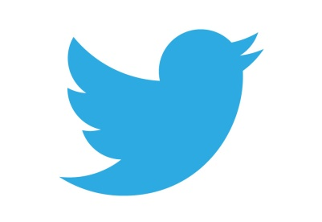
Twitter has announced that it overbilled video advertisers on Android due to a measurement error and has since refunded those affected by the mistake. Facebook also recently experienced ad measurement troubles, but its errors have not led to refunds.
Marketing Land 12/22/16
http://marketingland.com/twitter-overcharged-video-advertisers-due-error-android-app-201750

