Twitter Partners with CBS for National Convention Live Streams
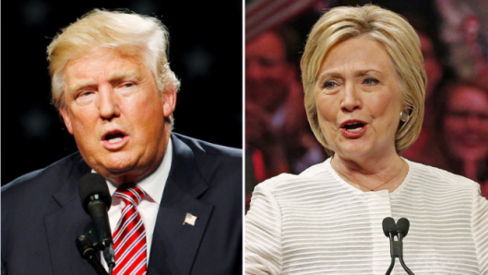
Twitter on Monday announced that it will team up with CBS to live-stream the Republican and Democratic National Conventions as part of its strategy to become a leader in live broadcasting. The conventions will be streamed across the company's mobile and desktop apps, and will feature real-time commentary in the form of related tweets.
MediaPost Communications 7/11/16
http://www.mediapost.com/publications/article/280037/twitter-to-stream-political-conventions.html

