Twitter, Samba TV Trial Audience Measurement
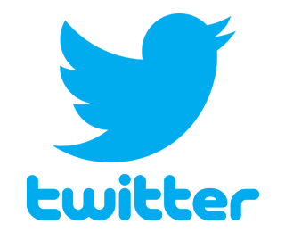
Analytics company Samba TV is working with Twitter to determine the platform's effectiveness of tying online engagement with viewership of cable, broadcast, over-the-top and sports programming. Samba Interactive TV is integrated with smart TVs from 14 manufacturers, and an initial test of 30 Twitter campaigns showed an average 28% lift in tune-in rate.
FierceVideo 3/28/19
https://www.fiercevideo.com/tech/twitter-and-samba-tv-team-up-for-tv-audience-measurement-trial

