Twitter Shuts Down Foreign Accounts with Malicious Intent
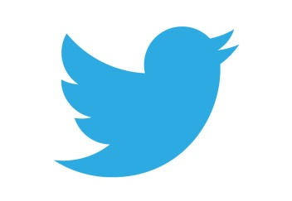
Twitter has uncovered more than 180,000 accounts operated by governments in China, Russia and Turkey that were being used to spread political information that was favorable to their respective countries and push disinformation and cryptocurrency-related spam and other commercial activities. According to a company blog post, the social platform shut down the accounts and shared relevant data with the Australian Strategic Policy institute and Stanford Internet Observatory.
Forbes 6/12/20
https://www.forbes.com/sites/daveywinder/2020/06/12/twitters-powerful-move-silences-175000-chinese-and-russian-fake-news-accounts-hong-kong-politics-social-media-disinformation/#20a2dfb721c9

