Imagine, a Newspaper Without a Website
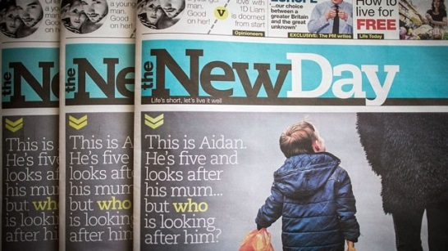
In the digital era, the London-based New Day has consciously chosen to forego what would seem like an essential element in 2016 to any business, most especially a newspaper. Digital requires more resources to break news and continually update it. By focusing only on print, The New Day argues, it saves both money and time.
MediaLife 3.7.16
http://www.medialifemagazine.com/imagine-a-newspaper-without-a-website/

