Univision Plans to Bring In Younger Viewers
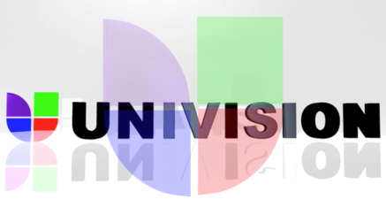
Univision has launched two original programs for YouTube and plans to release more in a bid to reach younger audiences. In addition to cashing in on the traditional YouTube monetization model, the company is also building a strategy around product placement and branded content, says Univision Interactive Media's Sameer Deen.
Digiday 11/27/17
https://digiday.com/media/univision-making-original-shows-youtube/

