Univision Plans to Offer Spanish-Language Streaming News
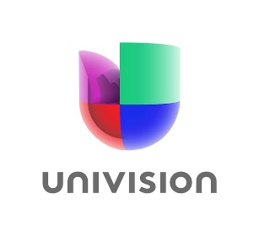
Univision is offering 24-hour Spanish-language news programming on its free PrendeTV platform. The company has been making ongoing investments in news aimed at Hispanic people, including a new Miami studio.
TV Tech 5.20.21
https://www.tvtechnology.com/news/univision-to-enter-24-hour-streaming-news-fray

