US Gives TikTok Nod for Sale, Temporary App Reprieve
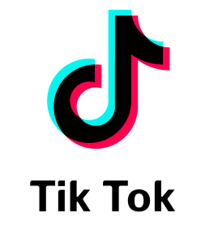
President Donald Trump gave his "blessing" to TikTok for the proposed sale of a stake in the app's US assets to Oracle, Walmart and other investors, while the Commerce Department maintained its ban on new downloads of TikTok and WeChat as of Sept. 20, but is allowing TikTok to operate until Nov. 12, pending the deal's final approval.
Reuters 9.21.20
https://uk.reuters.com/article/usa-china-tiktok-bytedance/update-2-chinas-bytedance-says-tiktok-will-be-its-subsidiary-under-deal-with-trump-idUKL3N2GI0FQ

