US Joins Ranks of World's Most Dangerous Places for Journalists
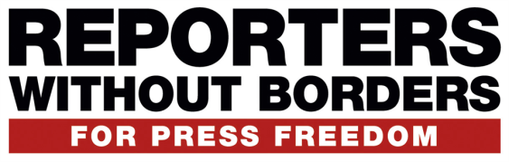
The U.S. was ranked one of the deadliest countries for journalists in 2018 for the first time in an annual report from Reporters Without Borders. The U.S. ranked sixth among the most lethal countries for journalists, behind Afghanistan, Syria, Mexico, Yemen and India, in that order. Six journalists were killed in the U.S. this year.
The Hill 12.18.18
https://thehill.com/homenews/media/421848-report-us-joins-ranks-of-worlds-most-dangerous-places-for-journalists-for-the?utm_source=sailthru&utm_medium=email&utm_term=ABN_MorningMediaNewsfeed&utm_campaign=MorningMediaNewsfeed_Newsletter_2018121908&s_id=5b11b32bf543e61eab1fd9e5&utm_source=Listrak&utm_medium=Email&utm_term=U.S.+One+Of+Deadliest+Nations+For+Journalists&utm_campaign=See+It+At+CES%3a+3.0%2c+5G%2c+IoT%2c+Connected+Cars

