Variety Examines Resilient Female Characters in Hollywood
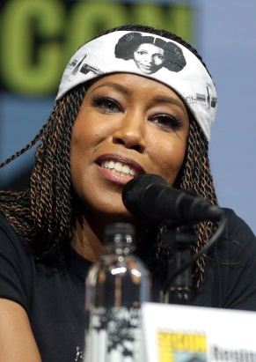
Variety examines several of Hollywood's strongest female characters on screen with insight from the protagonists empowered to bring them to life, including Hailee Steinfeld from "Dickinson" and Academy Award-winner Octavia Spencer from "Self Made: Inspired by the Life of Madam C.J. Walker." "The choice of Sister Night, in particular, is an extension of who she is but who she tucks away. I think it's a great visual metaphor for trauma and how we carry our trauma with us," says Regina King from "Watchmen."
Variety online 7.6.20
https://variety.com/2020/tv/features/regina-king-hailee-steinfeld-christina-applegate-mj-rodriguez-female-agency-tv-1234694874/
Image credit:
https://upload.wikimedia.org/wikipedia/commons/thumb/4/4c/Regina_King_by_Gage_Skidmore.jpg/1200px-Regina_King_by_Gage_Skidmore.jpg

