Vegas Broadcasters See Growth In Sports, News
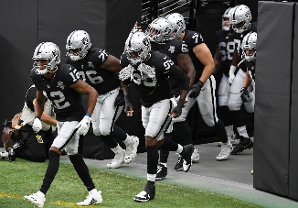
Las Vegas broadcasters are benefit from the town's success in becoming a major sports market, scoring its own NHL and NFL teams as well as the 2024 Super Bowl. Journalism is also a big business in Vegas, where stations are increasing local news content and developing in-depth investigative content to engage audiences.
Next TV/Broadcasting+Cable 8/18/22
https://www.nexttv.com/features/local-news-close-up-what-happens-in-vegas-a-lot?utm_source=SmartBrief&utm_medium=email&utm_campaign=45863C53-9E40-4489-97A3-CC1A29EF491D&utm_content=E2EEDBA2-2B56-448E-9770-C16A91ECB81D&utm_term=a25693a1-51b6-4112-bde4-56bd420e983f
Image credit:
https://www.sportscasting.com/wp-content/uploads/2020/10/Las-Vegas-Raiders.jpg

