Venice Days Festival: 50% of Films Directed by Women
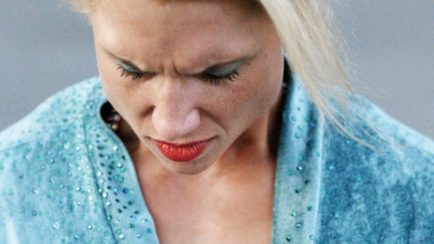
Half of the films screening at the independent arts festival Venice Days are directed by women, an increase from just one female director last year. "The choice was also the result of a search without borders and assumptions," Venice Days Director Giorgio Gosetti said. "We looked for the best, within what we could discover and have." Among the films selected for competition are Claire Burger's "Real Love," Elsa Amiel's "Pearl," and Sudabeh Mortezai's "Joy."
The Hollywood Reporter 7/24/18
https://www.hollywoodreporter.com/news/venice-days-unveils-lineup-films-directed-by-women-1129435
Image credit:
https://cdn1.thr.com/sites/default/files/imagecache/landscape_928x523/2018/07/pearl.jpg

