Verizon Asks FCC to Prohibit States from Protecting User Privacy
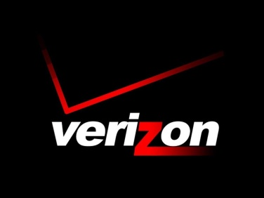
Verizon’s two-pronged attack on privacy protections for Internet users would require the FCC to not only abandon federal privacy protections (which is part of their Title II common carrier obligations), but to also prohibit states from protecting the privacy of their residents.
Electronic Frontier Foundation 11.3.17
https://www.eff.org/deeplinks/2017/11/verizon-asks-federal-communications-commission-prohibit-states-protecting-user

