Verizon Bets on Original Programming for Millennials with go90
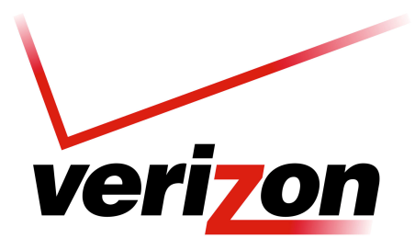
Verizon's free go90 mobile application is aiming to be the first port of call for millennials, and the company is creating around 50 original series by the end of this year. The company has teamed with Vice for lifestyle news, AwesomenessTV for comedy and the NFL and NBA for sports. "We're taking things that we think are working out there, but also carving out a couple original, exclusive and unique things that make us a little different," Verizon's Brian Angiolet said.
Business Insider 11/17/15
http://www.businessinsider.com/verizon-go90-app-2015-11

