Verizon Supports Female Filmmakers with $5M Fund
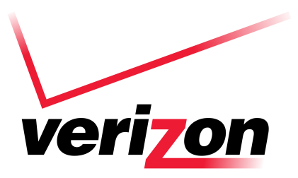
Verizon will invest $5 million in a Future Fund to support entertainment projects led by women in an effort to promote the potential of its 5G wireless network among filmmakers, give a lift to women behind the camera and boost its brand. Verizon said its initial project, "Not Done" -- which celebrates the centennial of the 19th Amendment that gave voting rights to women -- will air June 30 on PBS and stream on Verizon Media properties.
Variety online 2.11.20
https://variety.com/2020/digital/news/verizon-future-fund-5-million-women-filmmakers-1203500539/

