Verizon Will Provide 5G, Wi-Fi to Walgreens
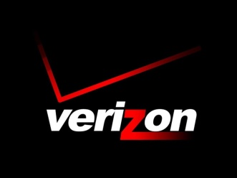
Verizon Business will provide 5G and 4G fixed wireless or fiber-based wireline networks to upwards of 9,000 Walgreens Boots Alliance stores in the US, with each location getting two connections. The network-as-a-service deal also calls for Verizon to install Wi-Fi networks inside all of the Duane Reade and Walgreens outlets within about a year.
Light Reading 12/16/20
https://www.lightreading.com/sd-wan/verizon-to-connect-9000-walgreens-duane-reade-stores/d/d-id/766165

