Viacom Greenlights "American Woman" for TV Land
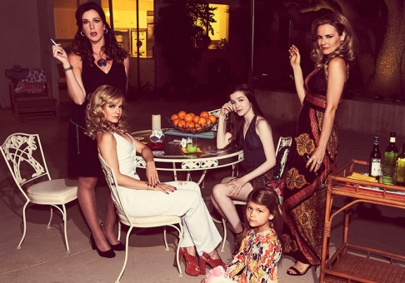
Viacom-owned TV Land has ordered 12 episodes of single-camera comedy series "American Woman." The original series, which is set in the 1970s and stars Alicia Silverstone, is to debut in 2017, joining other TV Land originals, such as "Younger" and "Lopez."
The Hollywood Reporter 11/7/16
http://www.hollywoodreporter.com/live-feed/alicia-silverstone-starrer-american-woman-ordered-series-at-tv-land-944864
Image source:
http://www.homorazzi.com/wp-content/uploads/2016/11/american-woman-tv-land.jpg

