Viewers Are Canceling Subscriptions, Seeking Free Content
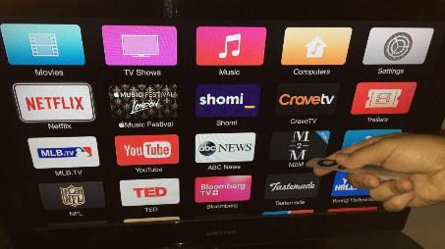
Consumers are cutting back on subscription streaming services and seeking out free, ad-supported content, according to a survey from LG Ad Solutions.
Next TV/Broadcasting+Cable 4.11.23
https://www.nexttv.com/news/viewers-are-canceling-subscriptions-seeking-free-content-lg-ad-solutions?utm_term=A25693A1-51B6-4112-BDE4-56BD420E983F&utm_campaign=C74FC4FA-5D4D-4151-8915-3043BA411DBE&utm_medium=email&utm_content=850A6AE8-8339-4211-AC24-8BB07FCC11D2&utm_source=SmartBrief
Image credit:
https://i.cbc.ca/1.3308161.1490373115!/fileImage/httpImage/image.JPG_gen/derivatives/16x9_1180/cord-cutting-tv.JPG

