Vimeo Plans to Become the Next Netflix at a Fraction of the Cost
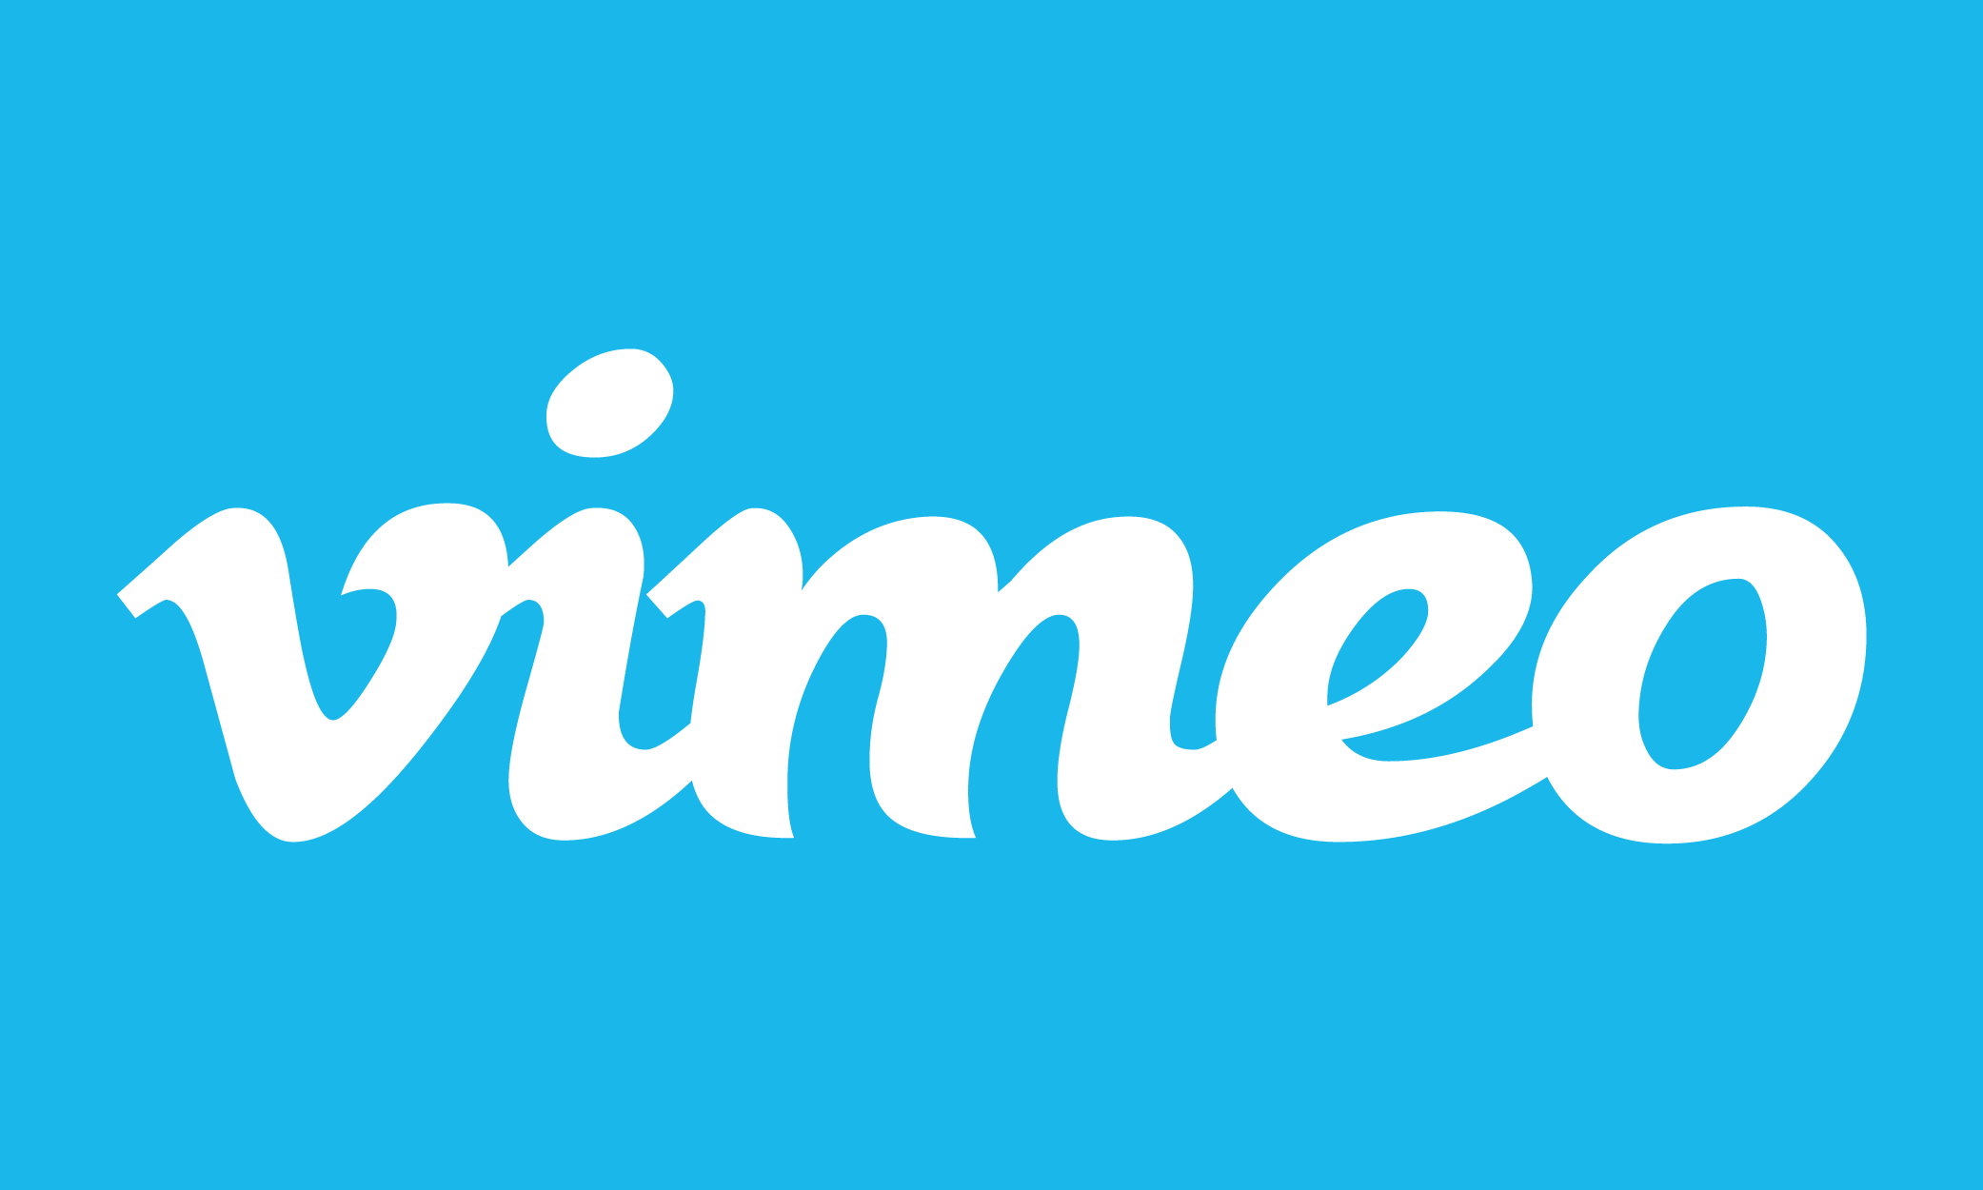
Vimeo plans to delve into subscription-video-on-demand by spending millions -- instead of billions -- to supplement Vimeo creators with original and licensed programming, per interim CEO Joey Levin. "I believe we can do so at a fraction of the cost of other major competitors by virtue of the audience and content benefits conferred upon Vimeo through our existing marketplace," Levin wrote in a letter to IAC shareholders.
Variety 11/2/16
http://variety.com/2016/digital/news/vimeo-svod-tens-of-millions-dollars-1201907431/

