Virtual MVPDs Added Over 1 Million Users in Q3
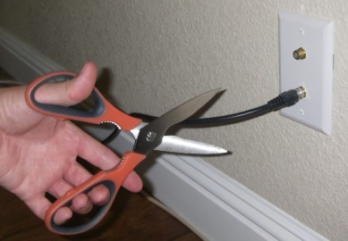
The top seven U.S. cable companies collectively lost nearly 981,674 pay TV customers in the third quarter, according to estimates and tallies collected by Leichtman Research Group (LRG). However, the heavy linear pay TV losses in Q3 were offset by the biggest growth quarter for virtual MVPDs in two years, with Hulu Plus Live TV, Sling TV and FuboTV combining to add 898,265 customers from July-September.
Next TV 11.15.22
https://www.nexttv.com/blogs/virtual-mvpds-added-over-1-million-users-in-q3-offset-huge-linear-pay-tv-losses?utm_term=A25693A1-51B6-4112-BDE4-56BD420E983F&utm_campaign=C74FC4FA-5D4D-4151-8915-3043BA411DBE&utm_medium=email&utm_content=3CBCF38C-F337-49AE-BCAA-5AC77F6FD5E6&utm_source=SmartBrief
Image credit:
https://www.stylemotivation.com/wp-content/uploads/2018/10/cord-cutting-2-620x431.jpg

