Volkswagen's Crisis Management Efforts Paying Off
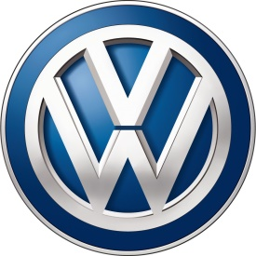
Effective crisis management has helped move Volkswagen beyond the emission scandal and back to being recognized as a top carmaker. "Our research shows that organizations which invest in building reputation experience less damage and recover more quickly following a crisis than organizations which do not," Niall Quinn of The Reputations Agency said.
The Drum (Glasgow, Scotland) 2/2/17
http://www.thedrum.com/news/2017/02/02/volkswagens-crowning-worlds-top-car-maker-triumph-crisis-pr-strategy

