Wanda Buys Dick Clark Prods. for $1 Billion
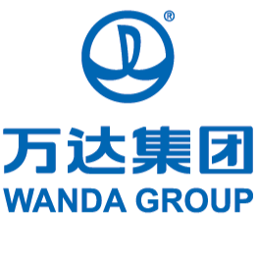
China's Dalian Wanda Group has added another entertainment trophy to its stable of overseas acquisitions, paying $1 billion for Dick Clark Productions, the TV company that produces the Golden Globes, the Billboard Music Awards, the American Music Awards, Dick Clark’s New Year’s Rockin’ Eve With Ryan Seacrest
The Associated Press 11.3.16
http://www.tvnewscheck.com/article/99049/wanda-buys-dick-clark-prods-for-1-billion?utm_source=Listrak&utm_medium=Email&utm_term=Wanda+Buys+Dick+Clark+Prods.+For+%241+Billion&utm_campaign=Scripps+3Q+Television+Revenue+Climbs+25%25

