WBAI Shuts Down Due to Financial Issues
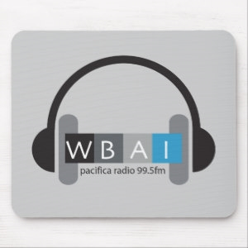
“Due to ongoing and continued projections of further financial losses at WBAI, local operations are being discontinued as of October 7, 2019,” Pacifica said in a statement. “We realize this news will come as a deep and painful shock, but we can no longer jeopardize the survival of the entire network.”
The New York Amsterdam News 10.8.19
http://amsterdamnews.com/news/2019/oct/07/wbai-shutting-down/
Image credit:
https://cdn3.volusion.com/axsfm.jvrla/v/vspfiles/photos/Mouse-2.jpg

