Wearables Become Increasingly Viable Marketing Tool
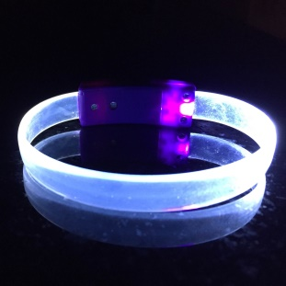
Technological advances and increasing consumer adoption of smartwatches, health monitors and other wearable devices have given marketers a unique opportunity to engage with consumers, glean actionable insights and even replace traditional touchpoints, writes Rosalyn Page. She points to creative wearable activations such as PepsiCo and Coca-Cola's use of Lightwave bracelets for concert crowd data and Jawbone's caffeine tracker that produces data allowing brands to cross-sell products.
CMO (Australia) 8.11.20
https://www.cmo.com.au/article/print/681977/state-wearables-2020/
Image credit:
https://cdn1.bigcommerce.com/server700/64bqhm/product_images/uploaded_images/led-wristband-blank-light-up-glow-bracelet-white.jpg?t=1448076144

