What Marketers Need To Know About Digital Accessibility
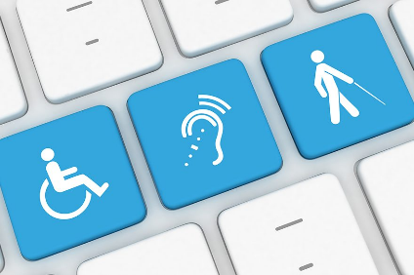
The digital shift that's accelerated during the pandemic makes accessibility an even more important issue, yet an AudioEye survey reveals a lack of understanding among managers, website designers and developers of accessible content. AudioEye President Dominic Varacalli explains what marketers need to know to make their digital content truly accessible for everyone and the legal requirements that need to be followed.
SmartBrief/Marketing 6/22/21
https://www.smartbrief.com/original/2021/06/digital-accessibility-survey-reveals-misunderstandings?utm_source=brief
Image credit:
http://mediawiremobile.com/news/wp-content/uploads/da-1-e1512152463722.jpg

