What Should You Say When the Press Calls?
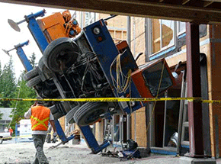
When a construction jobsite crisis occurs, experts say that communicating, not cocooning, is the best strategy. Amid the hectic scramble to respond and find answers, calls are coming in from local and perhaps even national media, all seeking information and comments. Now what? In fact, “now” is not the time to be asking this question.
Engineering News-Record 5.4.16
http://www.enr.com/articles/39380-crisis-communication-what-should-you-say-when-the-press-calls

