What Smart TV Means for Advertisers
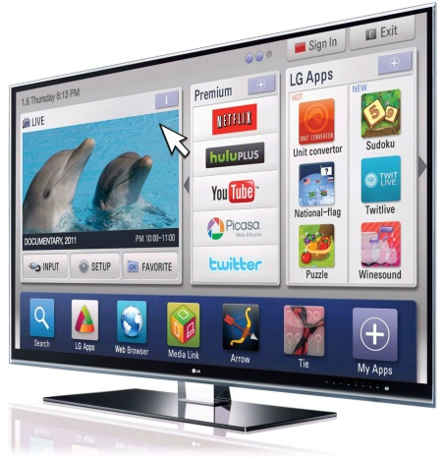
Matter More Media's Tracey Scheppach explains the opportunity for advertisers in the growing connected, smart TV market, including the need to serve useful content to viewers more likely to switch off from ads. She also discusses the potential of capturing data via IP addresses in cross-platform campaigns, and real-time ads for linear TV.
MediaPost Communications 4/28/17
https://www.mediapost.com/publications/article/300149/myriad-smart-tv-opportunities-are-poised-to-open-u.html

