What Stays on Facebook and What Goes? The Social Network Cannot Answer
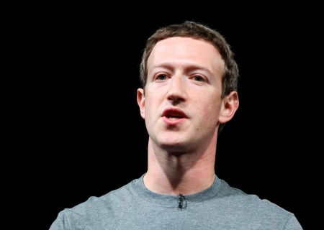
It’s been two years since an American presidential campaign in which the company was a primary vector for misinformation and state-sponsored political interference — and Facebook still seems paralyzed over how to respond.
The New York Times 7.19.18
https://www.nytimes.com/2018/07/19/technology/facebook-misinformation.html?utm_source=Listrak&utm_medium=Email&utm_term=View%3a+Facebook+Still+Stymied+By+Misinformation&utm_campaign=Tribune+Deal+Critics+Say+Drop+Merger+Or+Quit
Image credit:
http://www.slate.com/content/dam/slate/blogs/future_tense/2017/02/17/the_problem_with_mark_zuckerberg_s_new_facebook_manifesto_it_isn_t_political/511574500-founder-and-ceo-of-facebook-mark-zuckerber-gives-his.jpg.CROP.promo-xlarge2.jpg

