What to Expect at This Year's Upfronts
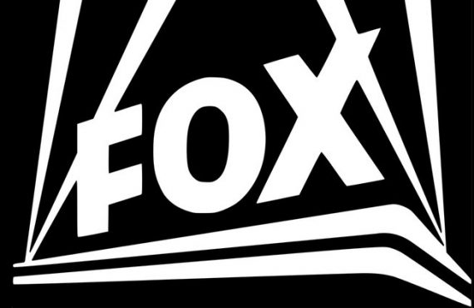
This year's upfronts will include a shakeup in the advertising landscape, with NBCUniversal and 21st Century Fox debuting strategies to reduce prime-time ad loads. New and returning lineups will be revealed as TV executives look to maximize linear and digital programming revenue.
Variety 5/12/18
http://variety.com/2018/tv/news/2018-tv-upfront-advertising-networks-prices-1202808207/

