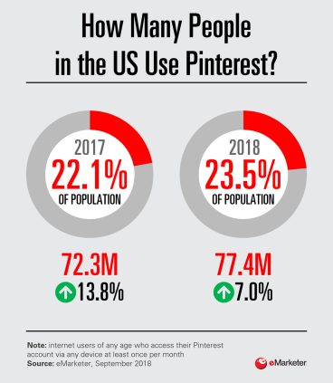
Who's Using Pinterest?
While Pinterest usage may skew female, the platform is diversifying demographically as the content evolves and gains broader appeal with millennial men—a push that makes sense since the social network is planning to go public by mid-2019.
eMarketer 10.25.18
https://www.emarketer.com/content/the-social-series-who-s-using-pinterest-infographic?ecid=NL1001
Image credit:
https://www.emarketer.com/content/the-social-series-who-s-using-pinterest-infographic?ecid=NL1001

