Why Apps Are A Prime Conversion Channel
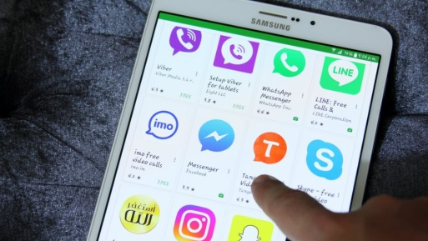
Just over 50% of mobile users say purchasing via an app is faster than via a website and 40% think there are more offers and discounts available on apps, according to an AdColony study. "Brands must keep in mind that mobile apps are not only where consumers are spending more time each day, but where they can make fast, informed decisions and go from awareness to conversion in a matter of seconds," AdColony's Jean Ortiz-Luis writes.
SmartBrief/Marketing 9/23/21
https://www.smartbrief.com/original/2021/09/full-funnel-marketing-age-mobile?utm_source=brief
Image credit:
https://www.komando.com/wp-content/uploads/2019/06/Android-apps-in-Google-Play-Store.jpg

