Why Digital Audio Could be the Biggest Ad Disruptor
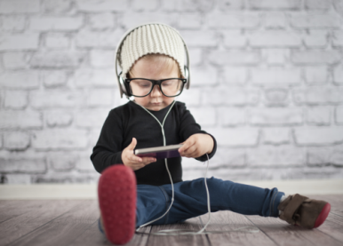
Roughly 75% of today's digital radio is listened to on mobile devices, which makes location and habit data available virtually everywhere. "What ultimately sets audio apart from display and video is the scope of its reach and the depth of its impact," said John Trimble, chief revenue officer at Pandora Media.
MediaPost Communications 2/3/17
http://www.mediapost.com/publications/article/294231/is-2017-the-year-for-audio.html
Image source:
http://www.fluentu.com/english/educator/blog/wp-content/uploads/sites/13/2015/01/a-model-lesson-for-using-songs-as-esl-audio-listening-materials1-e1422831856433.png

