Why PR Pros Need to Understand Copyright Rules
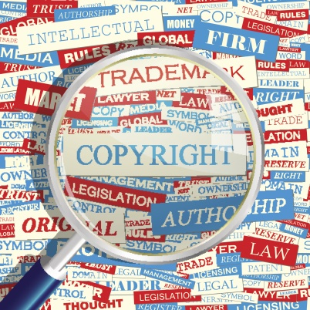
In the age of social media and copious information sharing, content is often modified, which makes it easy for communications pros to violate copyright laws unknowingly, writes Cayce Myers, APR. She outlines the four major copyright issues that PR professionals need to understand and explains the difference between copyright infringement and plagiarism.
PRSAY 7/29/19
https://prsay.prsa.org/2019/07/29/ethics-copyright-and-pr-practice-ethical-and-legal-considerations-for-communicators/
Image credit:
https://d1pet9gxylz2tx.cloudfront.net/uploads/2016/07/copyright-ThinkstockPhotos-463173161.jpg

